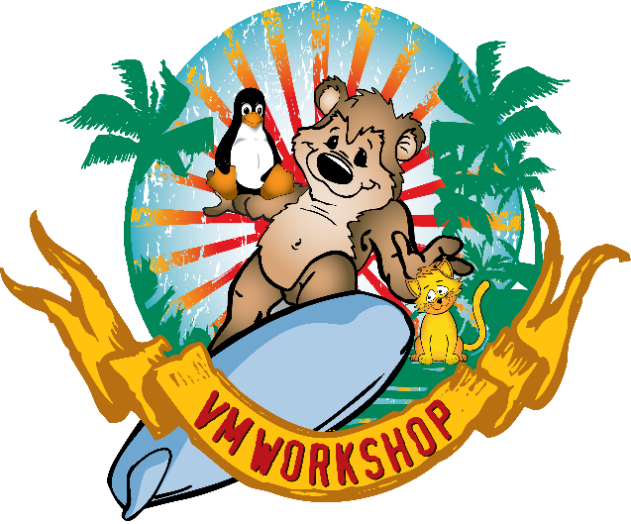
SAVE THE DATE!
VM Workshop 2020
June 18 – 20
The Ohio State University
Dear z/VM, z/VSE, and Linux on IBM Z Systems Professionals and Enthusiasts,
The 2020 VM Workshop dates have been set. The Workshop will be heading back to The Ohio State University in Columbus, Ohio for two and a half days packed full of education and networking.
Please mark your calendars and visit our website at www.vmworkshop.org for more information and the 2020 registration details. Please note that our early bird registration rate is $100 until April 30.
Feel free to forward this “save the date” announcement to your associates and mainframe friends who might be interested in this affordable educational experience. If you are not yet on our e-mail list, please visit www.vmworkshop.org to subscribe.
If you are interested in a sponsorship opportunity, check out our sponsors’ page for information and an application.

Looking for Speakers
For those of you who have unique or innovative experiences, productivity tools you use or have developed, or a career’s worth of pearls and scars, our attendees would love hear about them. Please submit a session abstract to us for consideration! Suggestions are always welcome for any topics you would like to see covered in the 2020 workshop. Please reply to this e-mail with your topic nominations.
Students Welcome
Finally, if you know or work with students interested in careers on the mainframe, please inform them that our student rate is only $10. See the registration page for more information.
The VM Workshop committee looks forward to seeing you in June 2020!

